The Anchor
Nebraska Admirals Association Summer 2023 www.nebraskaadmirals.org
Six sailors from the USS Nebraska visited: Grand Island, Kearney, North Platte, and Lake Manawa, Iowa. While in Grand Island, they were hosted by the admirals of the Grand Island Port. After arrival, they enjoyed an evening meal at a local steak house. The following day they had a tour of Hornady Manufacturing, and the Nebraska Building at the Nebraska State Fairgrounds. Lunch was at the United Veterans Club with the Admirals of the Grand Island Port. After lunch, the sailors visited the Nebraska Western Iowa Medical Center in Grand Island. They visited with several of the veterans at the clinic before departing for Kearney.
They were met by Mayor Stan Clouse at the Archway Monument in Kearney. After a quick tour of the westward expansion monument, they departed for North Platte. They enjoyed the Nebraskaland Days Rodeo and the Union Pacific Golden Spike Tower.
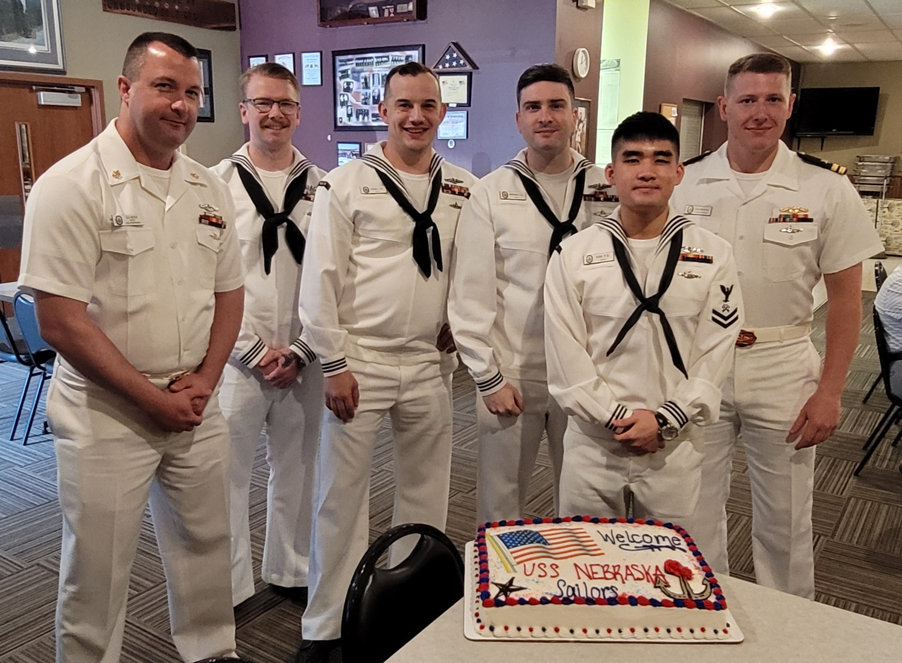
It was then time to head back to Omaha and the barbecue at Lake Manawa State Park (Iowa).
Sailors lunch at the United Veterans Club
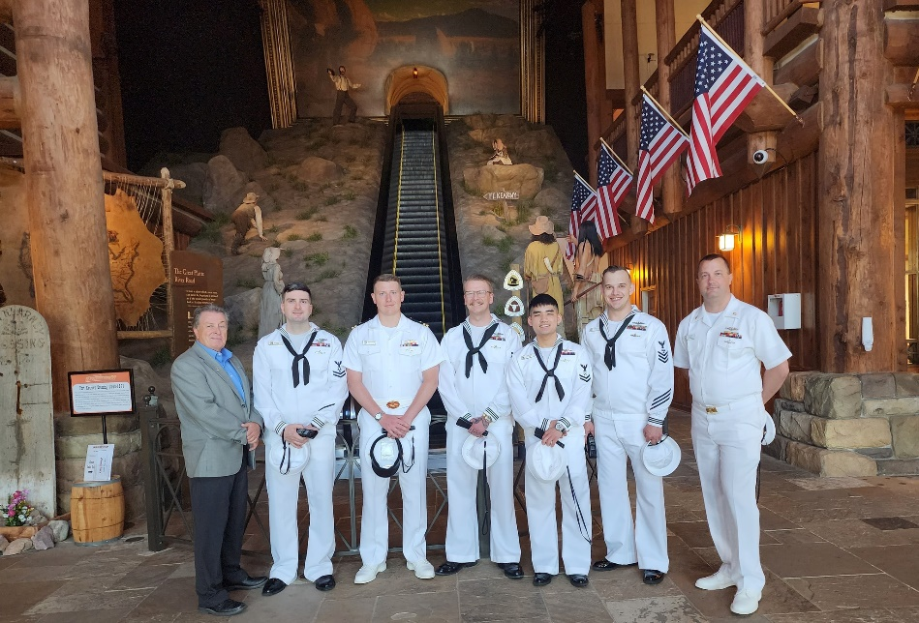
After an enjoyable stay-over in Grand Island, the sailors from the USS NEBRASKA SSBN 739, stopped at the Archway in Kearney to give them some views of this "west-ward ho" section of the USA. Thank you to the Great Platte River Road Archway and Kearney Mayor Stan Clouse for being the welcoming party!! The management of the Archway reports: "We enjoyed talking to them and having them with us. Thanks!"
(Photo credit to Archway Executive Director JoAnne H.)
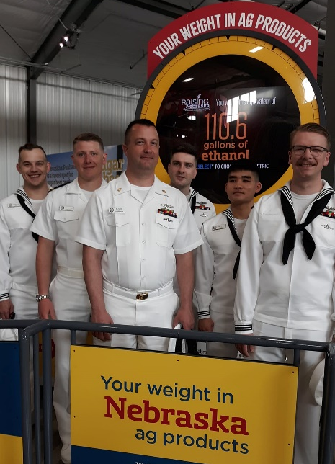
Ahoy! The USS NEBRASKA SSBN739 is reportedly 'the best-supported ship in the US Navy'!!! These sailors got to enjoy some 'famous-ness' while visiting the Grand Island port gathering on their way to Kearney, then North Platte, then Omaha this week. After bucking-broncos, they'll enjoy some baseball before sailing on Lake Manawa (Yeah, we know, it's in Iowa! ) and returning back to duty in Seattle. Go Big Red! (and thanks to the BRSC -- Big Red Sub Club -- of Omaha for sharing their visit across the namesake state!
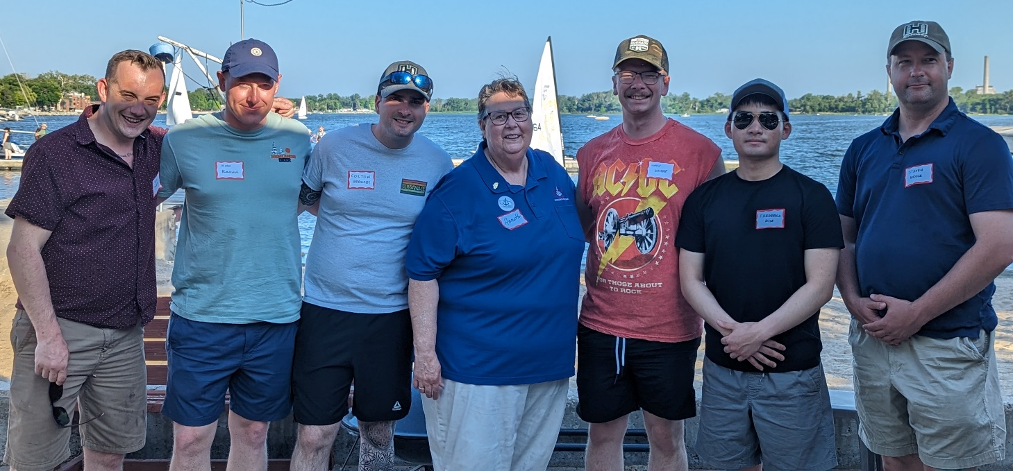
(Photo credit to Commander Annette Partridge)
Barbecue at Lake Manawa with Commander Annette Partridge.

About USS Nebraska (SSBN 739)
USS Nebraska (SSBN 739) is the 14th submarine of the Ohio class of ballistic missile submarines (SSBNs), and the second U.S. Navy ship to bear the name.
The keel of Nebraska was laid on July 6, 1987, and she was christened on Aug. 15, 1992, by Mrs. Patricia Exon, wife of U.S. Sen. J. James Exon. Nebraska was commissioned on July 10, 1993, at Groton, Conn., and assigned to Naval Submarine Base Kings Bay, Ga.
While stationed on the East Coast, Nebraska completed her first strategic deterrent patrol in August 1994 and became the first Ohio-class submarine to visit Europe and Halifax, Nova Scotia. In 1996, Nebraska was honored by U.S. Strategic Command (STRATCOM) as the SSBN recipient of the Omaha Trophy for excellence in strategic deterrence.
As part of an effort to balance the nation's strategic assets, Nebraska shifted her homeport to Naval Submarine Base Bangor, Wash., in October 2004. Since then, Nebraska has continued her tradition of excellence, receiving the Battle Efficiency Award (Battle "E") in 2010 and 2011. From: https://www.csp.navy.mil/nebraska/About/
Boat Characteristics
Class Ohio-class ballistic missile submarine
Displacement 16,764 metric tons surfaced
18,750 metric tons submerged
Length 560 ft (170 m)
Beam 42 ft (13 m)
Propulsion 1 x S8G PWR nuclear reactor
2 x geared turbines
1 x 325 hp (242 kW) auxiliary motor
1 x shaft @ 60,000 shp (45,000 kW)
Speed Greater than 25 knots (46 km/h; 29 mph)
Test depth +800 ft (240 m)
Crew 15 officers, 140 enlisted
Sensors and processing systems
BQQ-6 Bow mounted Sonar
BQR-19 Navigation
BQS-13 Active Sonar
TB-16 towed array
Armament MK-48 torpedoes
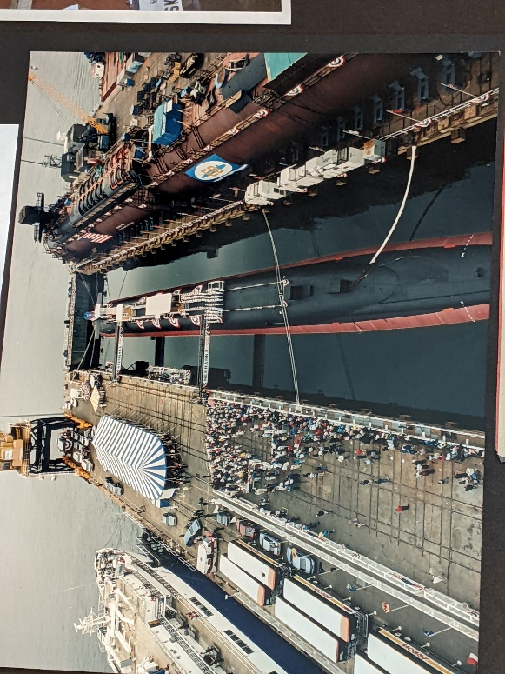
Up to 20 Trident II D-5 ballistic missiles
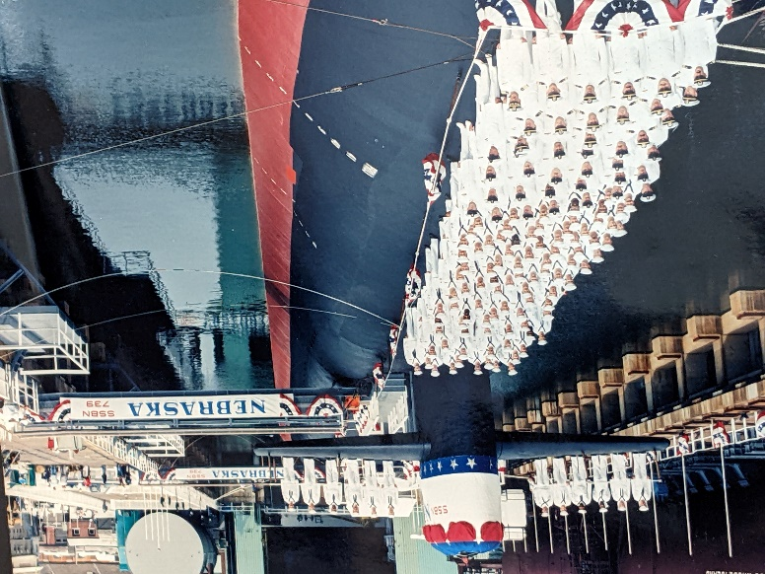
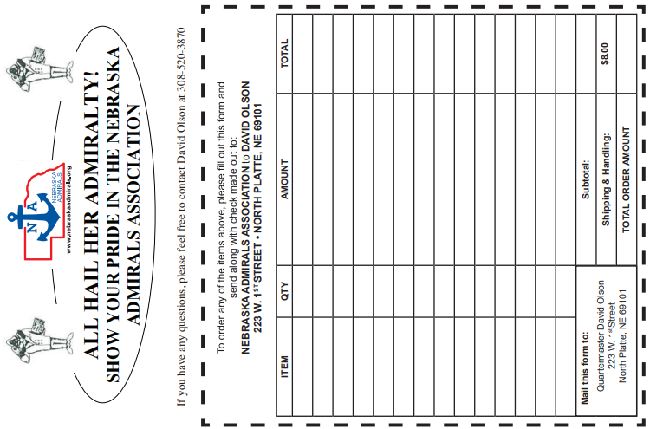
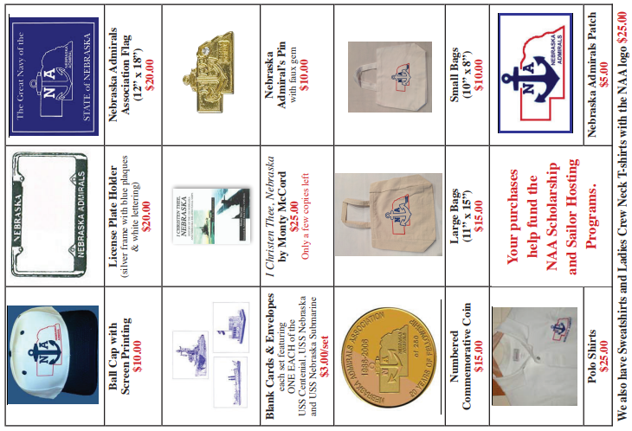
Shipping FREE on orders over $50
To order any of the items above, please fill out this form and send along with a check made out to:
NEBRASKA ADMIRALS ASSOCIATION
$10.00
Mail this form to:
Quartermaster Doug Brown
4017 Anna Marie Ave.
Grand Island, NE 68803
Doug Brown at: 308-390-5372
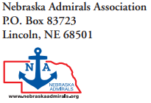

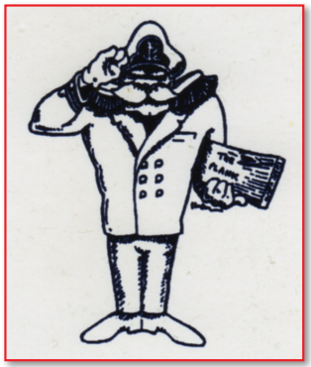
Visit our Web page http://www.nebraskaadmirals.org/
Follow us on Facebook

